1. GitHub account Creation process
2. Type code . for VS coder open
3. Mouse setting

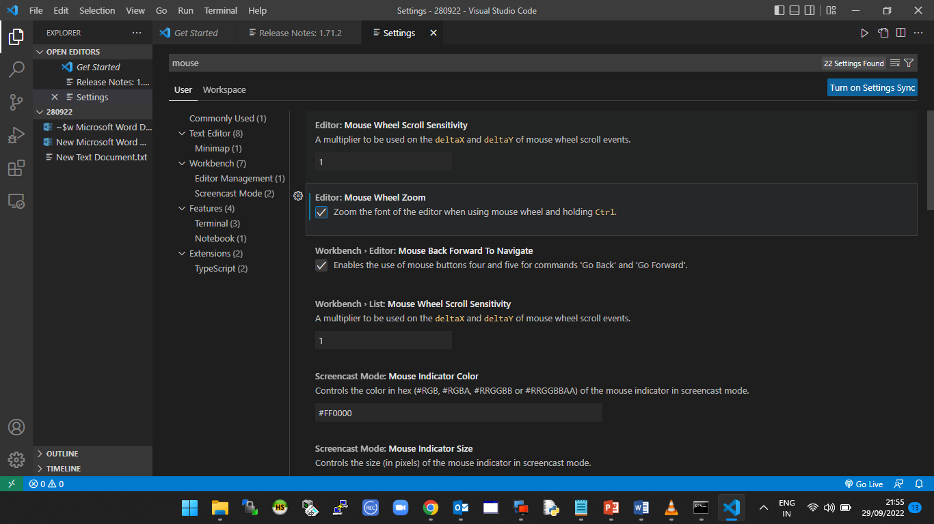

Wrap setting

